1. A F&B manager wants to determine whether there is any significant difference in the diameter of the cutlet between two units. A randomly selected sample of cutlets was collected from both units and measured? Analyze the data and draw inferences at 5% significance level. Please state the assumptions and tests that you carried out to check validity of the assumptions.

Minitab File : **Cutlets.mtw**

Given significance level=5%

H0:diameter of unit1 and unit2 are equal

H1:diameter of unit1 not equal to unit2

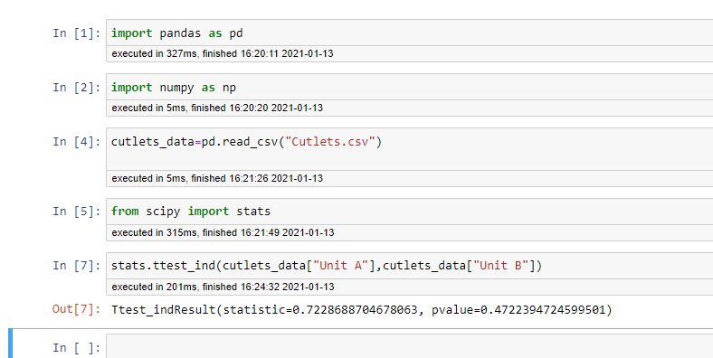

Here p value =0.4722

P>0.05

So accept null hypothesis

1. A hospital wants to determine whether there is any difference in the average Turn Around Time (TAT) of reports of the laboratories on their preferred list. They collected a random sample and recorded TAT for reports of 4 laboratories. TAT is defined as sample collected to report dispatch.

Analyze the data and determine whether there is any difference in average TAT among the different laboratories at 5% significance level.

Given significance level=5%

H0: there is no difference in average turn around time

H1:there is difference in average turn around time

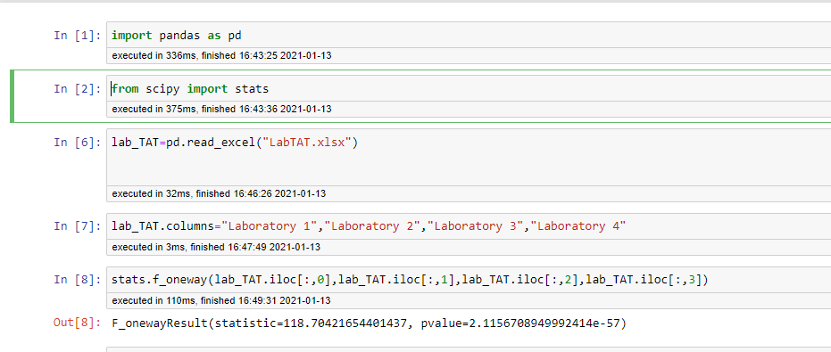

P value=2.1156

p>0.05

accept null hypothesis

1. Sales of products in four different regions is tabulated for males and females. Find if male-female buyer rations are similar across regions.

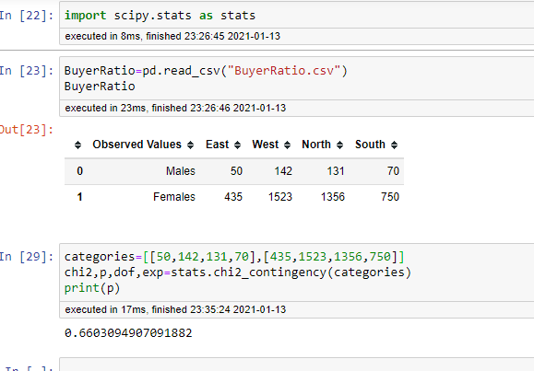

P=0.66030

P>0.05

So accept null hypothesis